**How to register for open/novice tournaments**

Open Tournament – Open to all levels of wrestlers

Novice Tournament – Normally for first and second year wrestlers only (each tournament should specify)

These tournaments do not replace our league Keystone Matches, but can be used to supplement your wrestlers mat time if they want to participate in more tournaments. Most tournaments have on-line registration and will have varying cutoff deadlines. You can find a listing of available tournaments at [www.pywrestling.com](http://www.pywrestling.com). These tournaments are listed in order of date.

[www.pywrestling.com](http://www.pywrestling.com)

Click on Tournaments – Events to see a list of open and novice tournaments available.



Each tournament listed will detail their own information such as weigh-in times, wrestling start times, award information, etc.

Scroll to see the tournaments available and then click on the tournament.

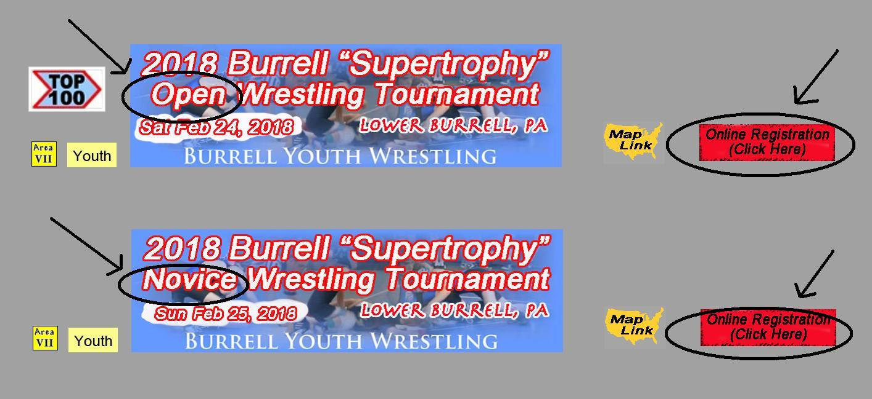

Tournament listings will show Open or Novice and if they offer online registration.

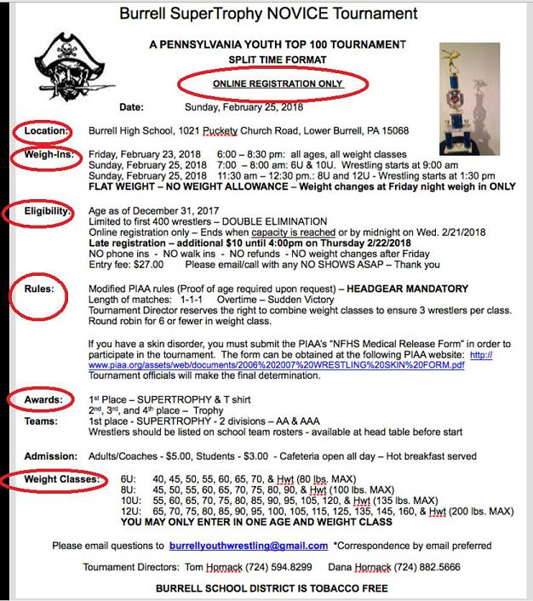

Once you click on the tournament, you can see all the necessary information for that particular tournament.